CRITICAL DESIGN REVIEW

BRISTOL ROCKETRY TOURNAMENT
2025-26
Astrosmith

Table of Contents
1.1. Mission Statement 1
2. Project management 1
2.1. Table of Team members 1
2.2. Project planning 2
3. Launch Vehicle Design 3
3.1. Launch vehicle overview 3
3.2. Launch Vehicle Components 7
3.3. Concept Of Operations (CONOPS) 8
3.4. Recovery System Design 8
4. Simulation data 12
4.1. Altitude vs time graph 12
5. Rideshare Payload 15
5.1. General Overview 15
5.2. Payload CONOPS 15
5.3. Equipment specifications 15
5.4. Power, Mass and Volume budgets 15
5.5. Battery Specification 15
5.6. Customer Payload integration 15
5.7. Payload Schematics 16
5.8. Custom PCB 17
5.9. Sensor Data 17
6. Systems Engineering 18
6.1. Requirements Compliance Analysis. 18
7. Assembly 18
7.1. Manufacturing plan 18
7.2. Interfaces and Integration 19
8. Testing 20
9. Improvements and Future Work 22
10. Acknowledgements 22
11. References 22
12. Appendices 22

- Introduction

Mission Statement
Our mission for this project is to launch our rocket to about 1500ft and the goal of avionics is to measure and record the IAS and altitude at fixed time intervals. We also aim to also recover rocket intact and the payload undamaged for analysis of data.

Project management

Table of Team members
Aerodynamics and Recovery | Structures | Avionics
Mukta | Chang Jun | Daniel
Sinfa | Everyone will play a part in structures during MR | Gabriel
Victor |  | Timothy
Hardik
Saransh
Budget
An up-to-date budget for the team.
Item | Cost
BMFA membership | £50
Materials: Plywood (Birch), Balsa etc. | £50
Custom components | £50
Recovery System (Parachute) | £15
Motor | £30
Custom PCB | £20
Total | £215 (£85 left of budget which may account to other things that come up during MR)

Project planning
Gantt Chart – Pre-emptive
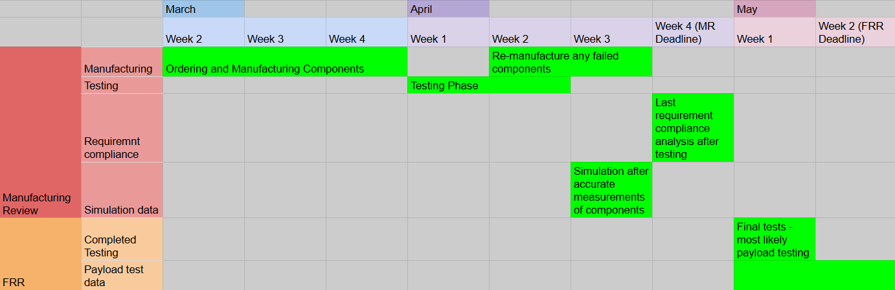
Work Breakdown Structure
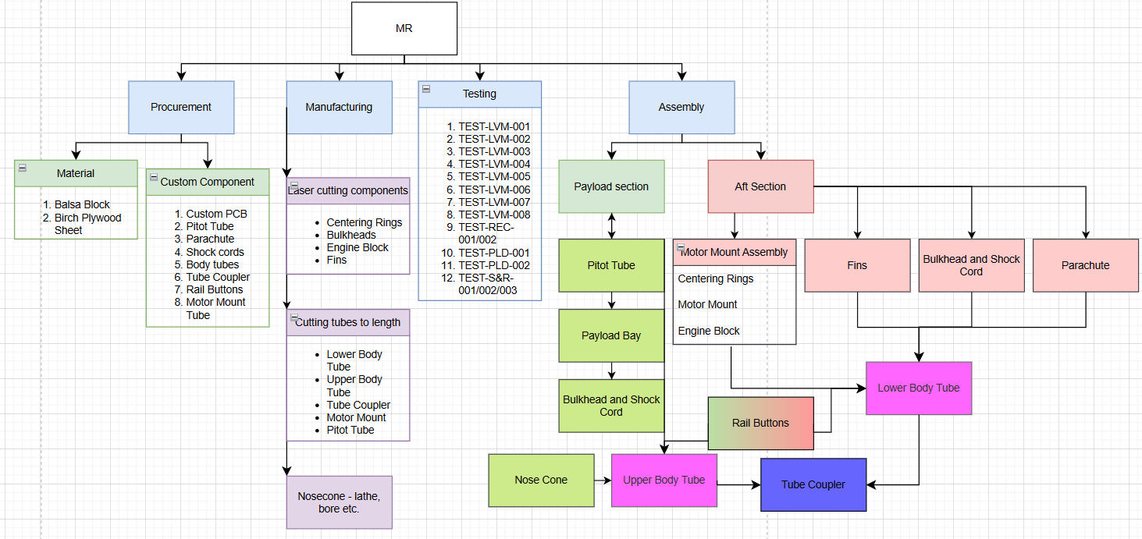
Critical Path Analysis
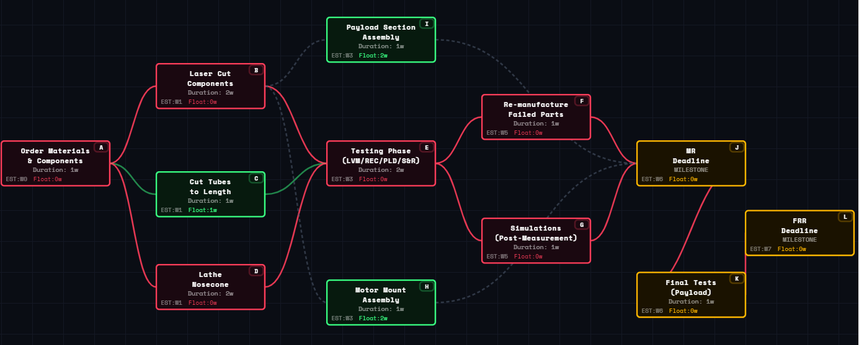

Launch Vehicle Design

Launch vehicle overview
Detailed and annotated Open rocket diagram ideally compared to a full CAD of the Launch Vehicle.
Key Design Changes: PDR to CDR
- Stability Margin Optimisation- Stability was adjusted from 2.45 to 1.67 to prevent it from exceeding 2.5 at the higher velocities of the flight profile.
- Altitude Change- The rocket is now specifically tuned to reach target altitude of 1500ft, a change from the previous 2000ft.
- Recovery System Transition- The design moved from a nose-cone deployment to a mid-break separation. To facilitate this new mid-break separation, internal birch plywood bulkheads and a tube coupler were integrated into design to provide strong anchoring points for the shock chords.
- Component Material Updates- Switching nose cone from Polystyrene (70g) to Balsa (14.5g) removed a huge chunk of weight which pulls the centre of gravity (CG) backwards, changing the stability.
-The body tube was upgraded from a single 70cm tube made of Balsa into a segmented body using Birch Plywood, making it heavier and closer to target altitude.
- The parachute shroud lines and shock cords using elastic cord were replaced by Kevlar 12-Strand which is flame resistant and will not melt or snap under the extreme heat or mechanical shock of the ejection charge.
- Engine block was added into the inner tube. Standard trapezoidal fin with a height of 5cm was switched to a freeform fin shape with an increased height of 8cm and mass. This change increased the surface area of the back and anchor the centre of pressure (CP) to the rear.

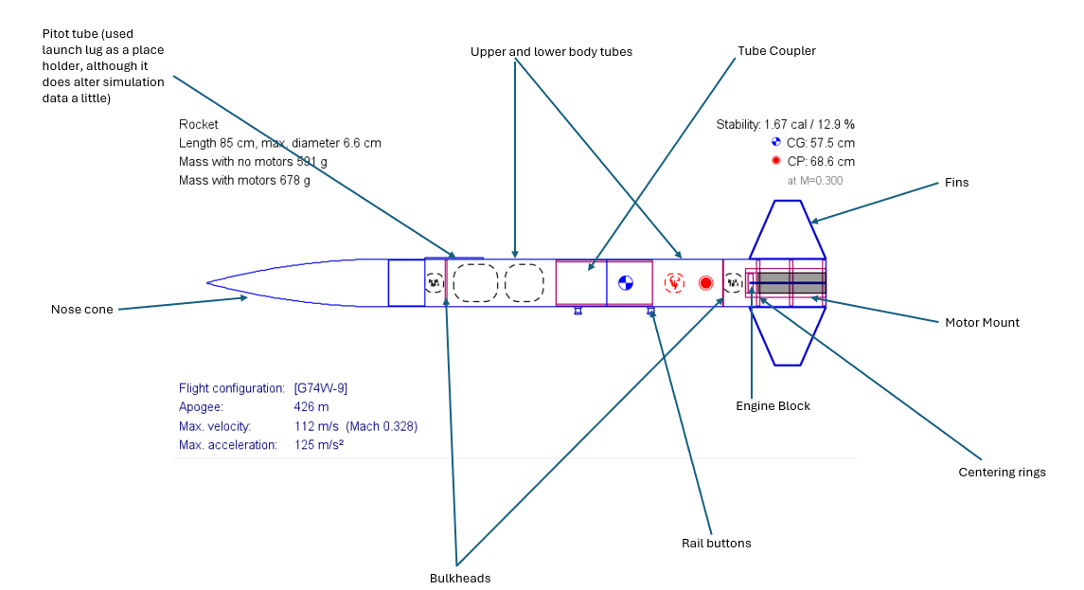
Figure 1: Labelled OpenRocket Diagram
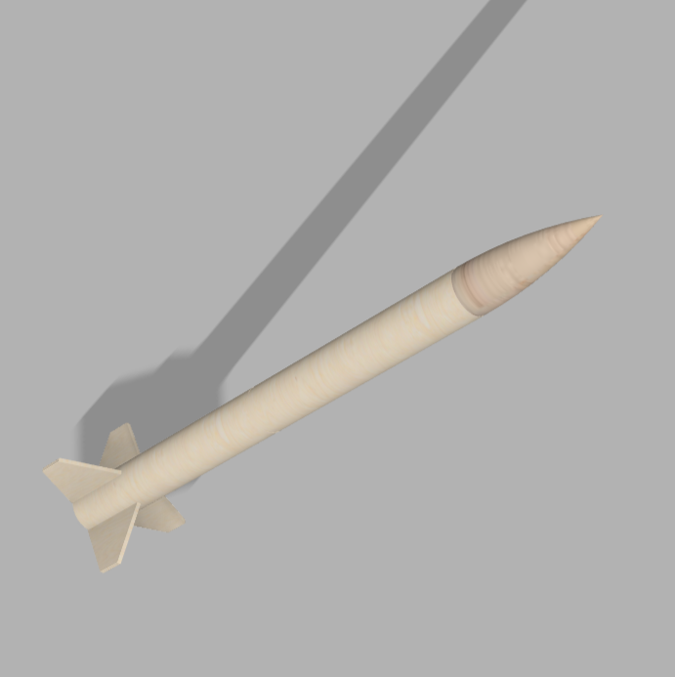
Figure 2: Full CAD Diagram of the Launch Vehicle
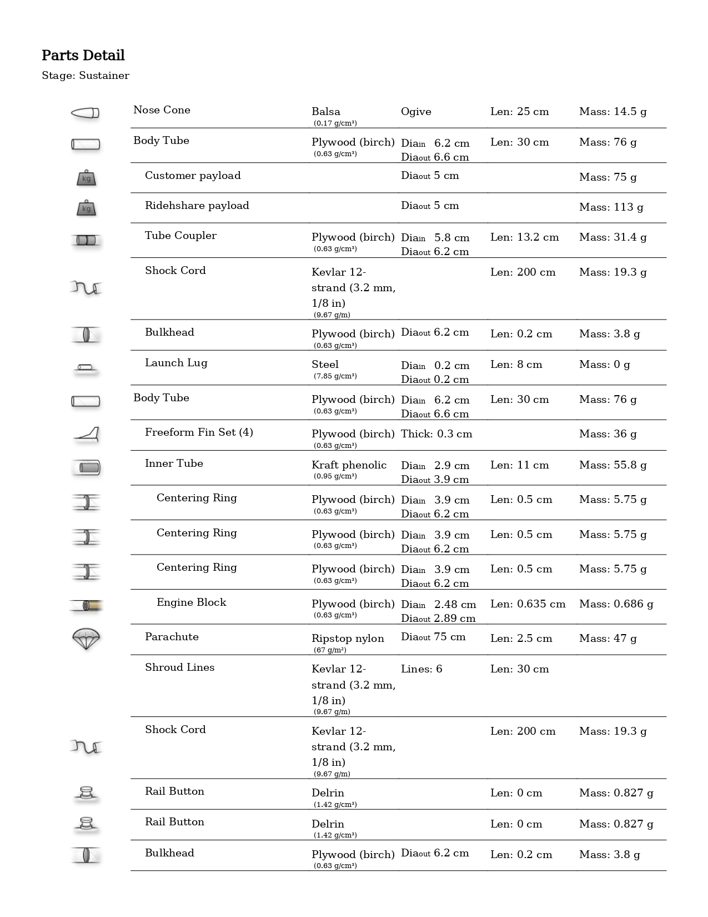
Pros and Cons of all materials chosen
Materials | Components | Pros | Cons
Balsa | Nose Cone | Extremely light and easily shaped into perfect ogive by hand | Very soft and might be damaged during landing or transport due to low compressive strength
Plywood (Birch) | Centering Rings | Keep motor mount tube perfectly aligned and can withstand high pressure during motor ignition | Heavy and difficult to sand into perfect friction fit inside body tube
 | Bulkheads | Strong anchor for shock cord and eye bolt. | Adds significant weight to the airframe
 | Body Tubes | Stiffer and heat resistant. Smooth exterior surface for better aerodynamics | Brittle, may crack or shatter if rocket lands on rough surface
 | Fins | Strong enough to withstand landing impact without snapping. Stiff enough to prevent fin fluttering at high speed | Heavier than balsa fins which shift the Centre of Gravity back, reducing stability
Ripstop Nylon | Parachute | High strength so it won't tear during high-speed deployment | Might need fire resistant protector to prevent melting
Kraft Phenolic | Motor Mount Tube | Durable and heat resistant. Less likely to tear under the pressure of ejection charge | Brittle, may crack or shatter if rocket experience a rough landing.

Motor used: G74W-6 (From G74W-9 to G74W-6, 7.68 second delay)

Launch Vehicle Components


Motor Mount Assembly
- The assembly consists of inner tube made of Kraft phenolic surrounded by two centering rings made of plywood (birch).
- The centering rings make sure the motor tube fits securely and perfectly centered within the 6.6 cm outer airframe
- This entire assembly sits at the end of the rocket to house the G74W-6 motor and transfer its thrust directly to the airframe

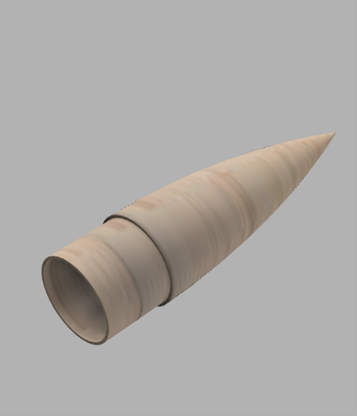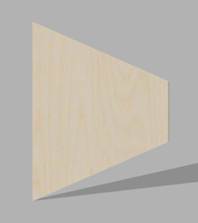
Fins
- The rocket utilises a set of 4 freeform fins constructed from plywood (birch) to maintain aerodynamic stability
- Each fin was designed with an airfoil cross-section and has a thickness of 0.3 cm
- The shape is trapezoidal with a root length of 10.5 cm along the body tube and extending outward to a span of 8 cm
- The complete fin set has a combined mass of 36 g and coated with regular paint finish
Nose cone
- The rocket utilises a solid ogive aerodynamic profile and is constructed from balsa. It is positioned at the front of the 85 cm rocket assembly.
- It features a stepped shoulder at its base, which is designed to slide directly into the upper body tube to secure the forward airframe

Concept Of Operations (CONOPS)
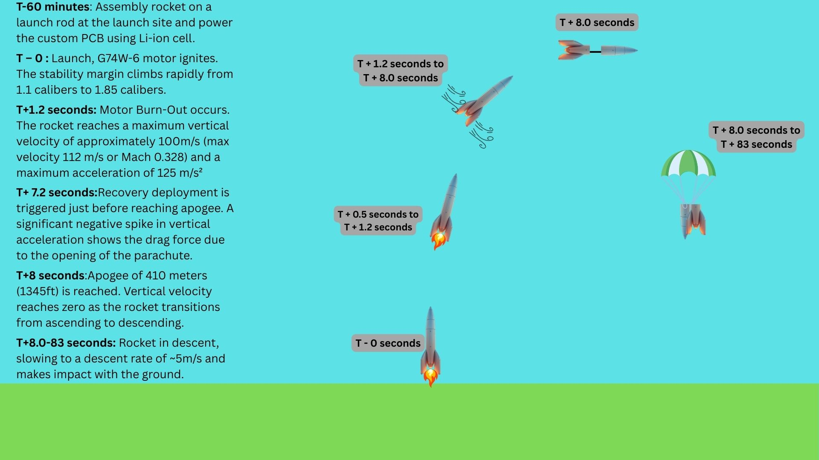

Recovery System Design
3.4.1 Recovery System Overview
The rocket utilises a single-deployment parachute recovery system designed to safely return the launch vehicle to the ground while minimising structural loads and drift. The recovery system is deployed at apogee using motor ejection charges. At deployment the rocket separates at the mid-body coupler, allowing the parachute to extract from the forward part of the airframe.
The recovery system consists of the following components:
- Ripstop Nylon Parachute
- Kevlar shock chord
- Internal bulkhead with eyebolts
- Tube coupler forming the avionics bay
- Parachute compartment located in the forward body tube
During flight the rocket remains as a single rigid airframe. Once the ejection charge activates at apogee, the rocket separates into two sections connected by a Kevlar shock chord. The parachute deploys and inflates, reducing the descent velocity to a safe landing speed.
The Kevlar shock cord length exceeds the minimum requirement of 2 m to reduce deployment loads and prevent the rocket sections from colliding.
3.4.2 Recovery Deployment Method
Recovery deployment is triggered by the motor delay and ejection charge of the G74W-6 rocket motor. After burnout, the rocket enters a coasting phase where it continues to gain altitude until reaching apogee. Once the delay grain burns out, the ejection charge ignites and produces a rapid pressure increase inside the body tube.
This pressure forces the rocket to separate at the mid-body coupler. The nose cone and upper body tube are pushed forward, allowing the parachute to exit the body tube and inflate in the airflow. The parachute is attached to the shock chord, which connects the upper and lower rocket sections.
The deployment event produces a rapid deceleration spike due to the sudden drag generated by the parachute. This behaviour can be observed in the simulation data, which shows a sharp decrease in vertical velocity shortly after apogee.
During parachute deployment the drag force is transmitted through the parachute shroud lines to the Kevlar shock cord. The shock cord transfers the load to eyebolts mounted on the internal bulkheads, ensuring that recovery loads are carried by the structural bulkheads rather than the body tube.
3.4.3 Avionics Bay Design
The recovery system incorporates a dedicated avionics bay integrated within the tube coupler. This module houses the flight computer and electronics required for flight data collection.
The avionics bay consists of:
- A coupler tube connecting the upper and lower body tube
- Two internal plywood bulkheads
- Three M4 threaded rod forming a three-point structural cage
- A central avionics sled mounted between the rods
- Vent holes in the coupler wall to equalise pressure
Vent holes are included in the coupler wall to ensure the avionics bay remains unpressurized, allowing the flight computer to accurately measure atmospheric pressure throughout the flight.
Three threaded rods were selected as they provide a stable triangular structural frame while minimising additional mass compared to a four-rod configuration.
The recovery system satisfies the competition requirements by deploying a parachute at apogee and reducing the landing velocity to below 15 m/s.
3.4.4 Recovery Sequence
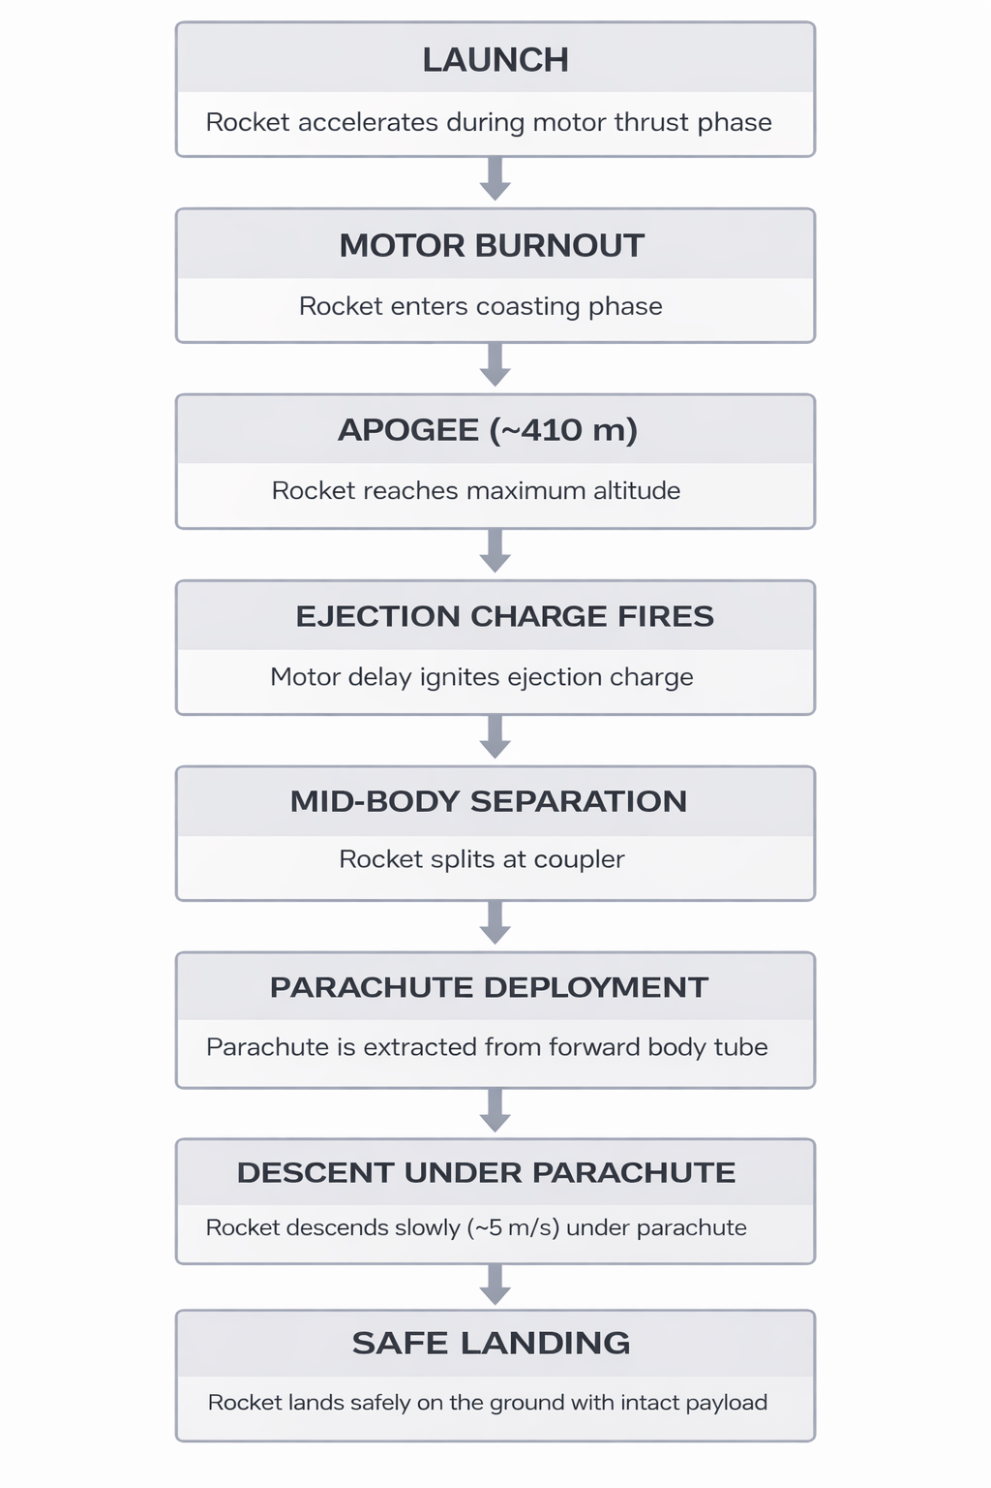
Figure 3.4.1: Recovery system operational sequence showing the key events from apogee detection to safe landing. After reaching apogee (~457 m), the motor ejection charge activates, causing mid-body separation and parachute deployment. The parachute then reduces the descent velocity to approximately 5 m/s, allowing a safe recovery of the rocket.

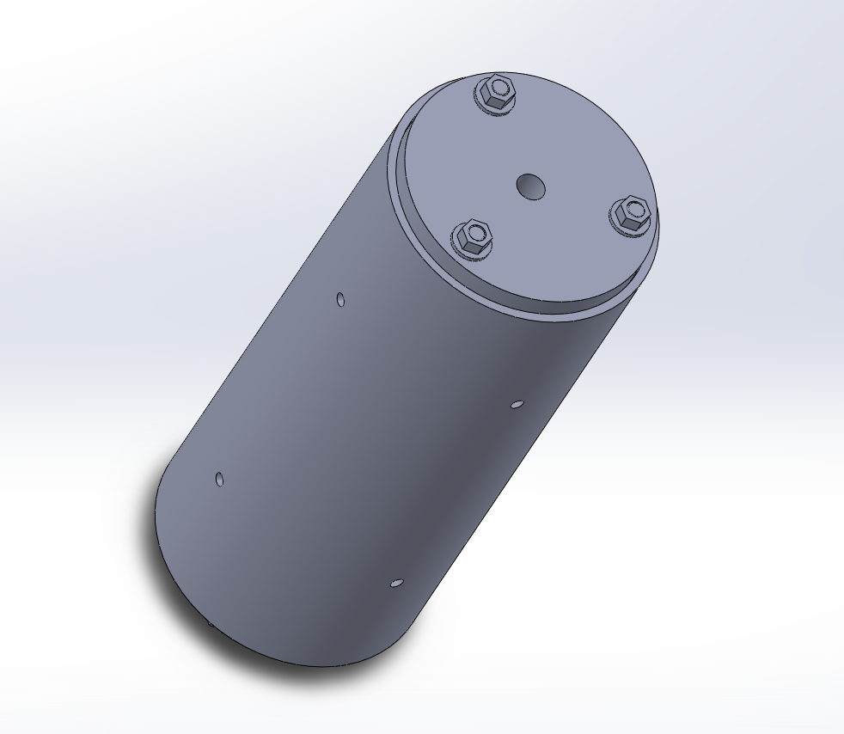
Figure 3.4.2: CAD model of the avionics bay assembly showing the threaded rod structural cage and electronics sled used to support avionics hardware.
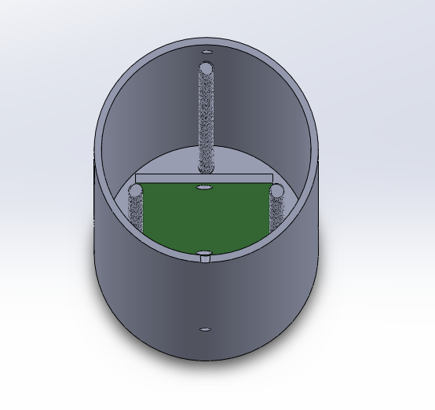
Figure 3.4.3: Internal view of the avionics bay illustrating the three threaded rods and central electronics sled used to support avionics hardware.
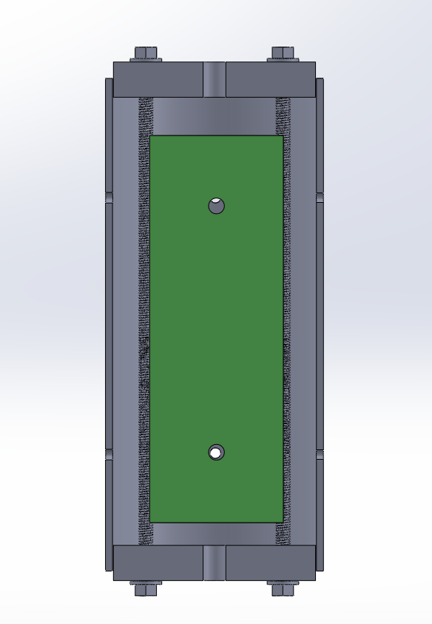
Figure 3.4.4: Section view of the avionics bay showing the internal mounting arrangement of the electronics sled between the threaded rod supports.

Simulation data
  - Altitude vs time graph
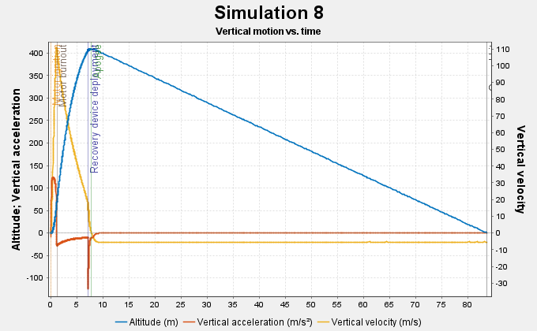
- Thrust phase (0s –1 .2s): The rocket at this period accelerates sharply, reaching a maximum vertical velocity of approximately 100m/s (yellow line) at motor burnout.
- Apogee (~8.0s): The rocket reaches maximum altitude of 410 meters (blue line), which is equivalent to 1345ft. As the vertical velocity reaches zero at this point, the rocket transitions from ascending to descending.
- Recovery deployment (~7.2s): A deployment event is triggered just before reaching apogee. The vertical acceleration (red line) shows a significant negative spike, showing the drag force due to the opening of parachute, which slows down the rocket at a descent rate of ~5m/s.
  - Stability vs time graph
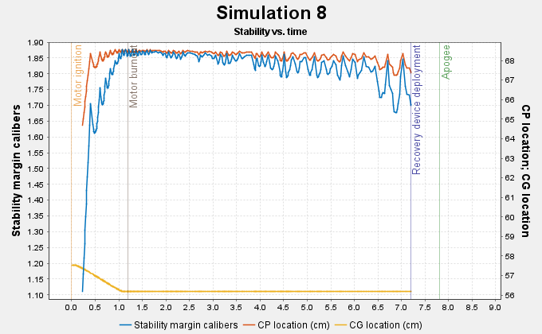
- Motor ignition (0s-0.5s): As the motor ignites, the stability margin (blue line) climbs rapidly from 1.1 calibers to ~1.85 calibers due to the rapid movement of the CG (yellow line) forward.
- Motor burnout (~1.2s): At this point, the CG stabilizes as the propellant is exhausted. The stability margin remains high throughout the coasting phase (1.7-1.9 calibers)
- After-burnout oscillations: The fluctuations in stability during the coasting phase reflect the changes in the rocket’s angle of attack (α). As the rocket reacts to aerodynamic forces, the CP (red line) shifts slightly, but the rocket remains stable throughout.
CORE ASSUMPTIONS:
- The rocket is treated as a single rigid airframe, any vibrations are not modelled
- The simulation assumes a standard atmospheric density model
- Air is assumed to be incompressible flow around the airframe.
SETUP CONDITIONS:
- The motor used in this simulation is G74W-6.
- The average windspeed assumed in this simulation is 3m/s with a deviation of 0.5m/s.
- The length of the launch rod is set to 100cm, with the launch site having an altitude of 10m.

Rideshare Payload

General Overview
The rideshare payload is to record air speed, and altitude. It incorporates a built-in power source which can be replaced with disposable coin batteries. Pitot tube will be used to find dynamic pressure while static pressure found using static ports on the rocket.

Payload CONOPS
The sensors will start recording data on start up when the power source is enabled on. Due to the large internal memory, memory constrains is not an issue so we can afford to keep the logger running at all times. The logger will stop upon recovery when the power source is turned off.

Equipment specifications
This PCB is fully custom thus only using resistors, capacitors, sensors which are described below (5.7). All rated for 3.3v apart from the differential pressure sensor rated for 5v which is overcome with a linear regulator just as the 3.3v components.

Battery Specification
In compliance with university battery storage, this solution has opted for the use of 2 CR2032 lithium manganese dioxide coin batteries which will be stored on the surface mount of the PCB. The nominal voltage of power supply is 6v.

Customer Payload integration
PCB will be screw mounted on the inside of the rocket with the pitot tube being sent through the nosecone of the rocket into the undisturbed airflow. The top half of the rocket will contain the PCB securely fastened.

Payload Schematics

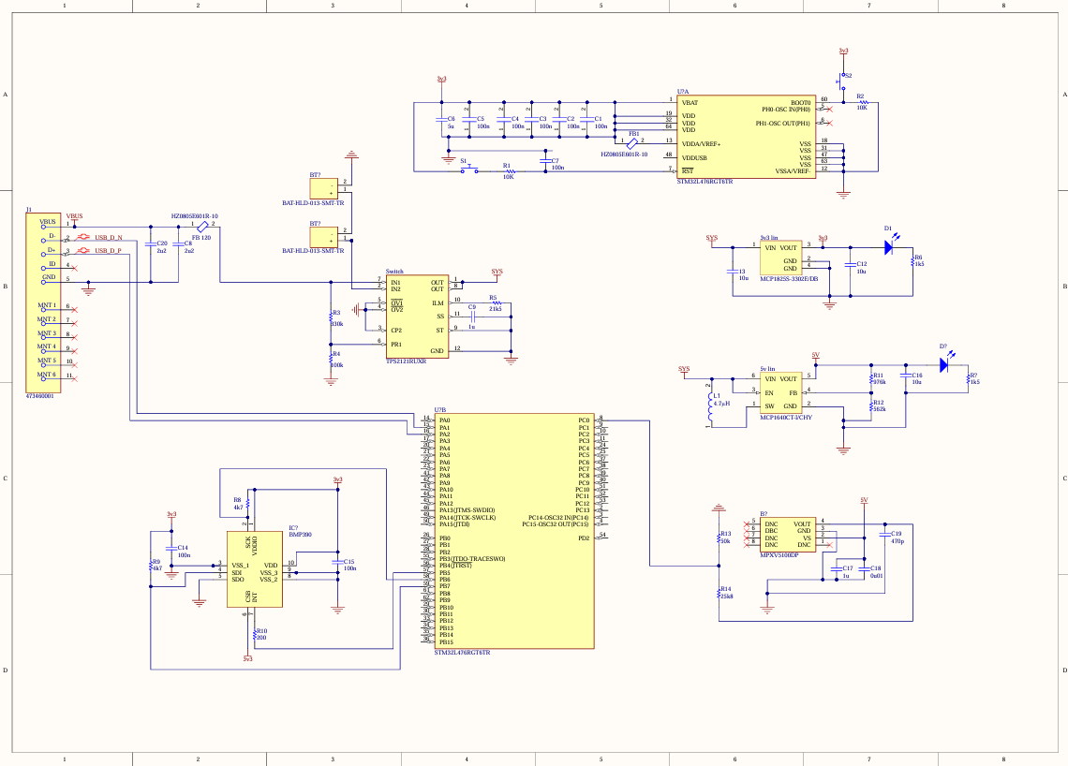

Custom PCB
The rockets PCB will be a fully custom-made PCB made in Altium which will use an STM32 microcontroller as the main processor. It will have 2 main instruments form recording data which are the differential pressure sensor (MPXV5100DP) which will record the indicated air speed using a pitot tube coming out of the rocket nose cone and a separate digital pressure sensor (BMP390) which will be used to find the altitude of the rocket during its flight. The upper body of the rocket will incorporate static holes to aid the differential pressure sensor in calculating the correct airspeed. Also incorporated into the PCB, there are 2 linear voltage regulators (MCP1825S-3302E/DB, MCP1640CT-I/CHY) where one will drop the voltage down to 3.3v which the microcontroller will use as well as the pressure sensor. Another linear regulator is a step down to 5v when battery is being used as the main source of power for which the differential pressure sensor will use. 2 CR2032 lithium manganese dioxide coin batteries have been chosen as the power supply for the PCB which will be surface mounted and can be replaced since freely available and cheap while also falling within university policy since no Li-Po batteries. The 2 cells will be connected in series providing a nominal voltage of 6v.

Sensor Data
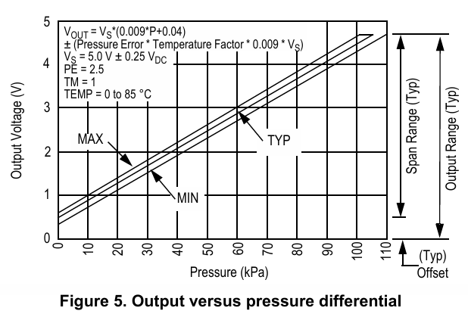

MPXV5000DP outputs

Systems Engineering

Requirements Compliance Analysis.
Here is a snippet of the Requirements Management Document used to keep track what requirements have been met, which ones require any physical tests and once we get to the testing phase we will produce a similar Testing Management Document, where it will show which tests have been conducted and the results/ any adaptations required.
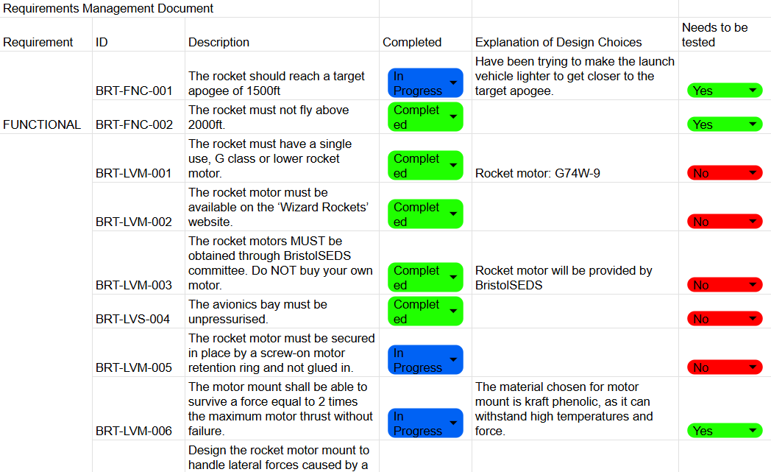

Assembly

Manufacturing plan
The focus for the first 3 weeks of the manufacturing phase will be ordering and machining our components ready for the next two weeks of testing. This allows us time to re-machine any components that failed any of the tests before re-testing. Here is a table with our components and their manufacturing IDs and initial ideas on manufacturing techniques we will use to machine the components.
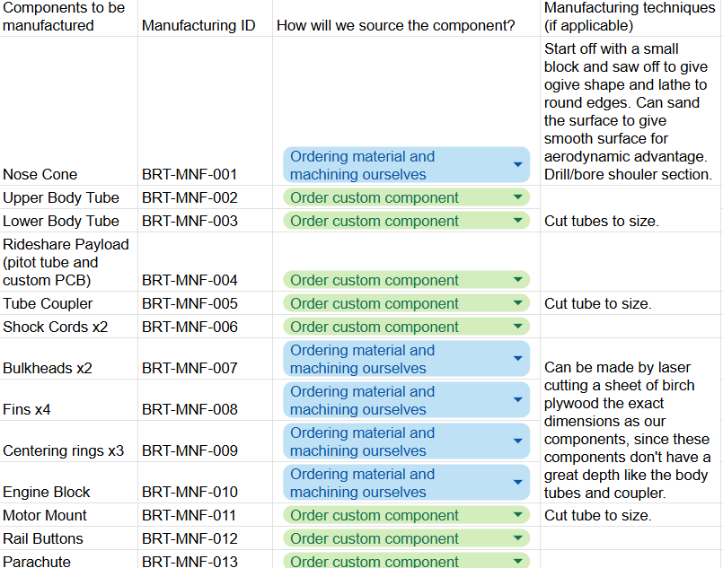SQ1 `````````,./

Interfaces and Integration
- How will complex segments of the rocket be assembled once individual sections have been manufactured?
Once Individual sections have been manufactured, we will conduct tests to see if the components pass the requirements set out in section 6.1, we will then start thinking about the assembly.

- How will the stages interface (connect)?
The Payload Section consists of upper body tube, a bulkhead, pitot tube, a rail button, a shock cord, avionics bay.
These components will be integrated by:
The bulkhead will be installed into the upper tube using epoxy. We will then attach one of the shock cords to the bulkhead. We will test the pitot tube with the avionics and once it meets our requirements it will be screwed/attached in to the top of the upper body tube and connected to the avionics bay which should be able to slide in. The rail button will be screwed in once the accurate position of the centre of gravity is measured, and then it will be placed 5 cm above it.

The Aft Section consists of lower body tube, motor, motor mount, engine block, centering rings, fins, bulkhead, parachute, shock cord, a rail button.
These components will be integrated by:
The bulkhead and shock cord will be attached in a similar manner as in the upper body tube except here it will be closer to the bottom of the lower body tube, above the motor mount assembly. The parachute can be attached to the shock cords and will be above the bulkhead. The centering rings will be attached to the outside of the motor mount using epoxy and the engine block inside the motor mount also using epoxy. Attach the motor mount assembly to the bottom of the lower body tube using epoxy. The fins will be attached to the base of the lower body tube using epoxy, and epoxy fillets will be applied to all the fin joints. The rail button will be screwed in once the accurate position of the centre of gravity is measured, and then it will be placed 5 cm below it in the aft section.

The sections will then be joined together by the tube coupler, which will be secured with epoxy to the upper body tube and will then be friction fit to the aft tube so that it can separate when recovery system is deployed. Aerodynamic load testing is conducted for this reason, to test to see if the friction fit holds. The nosecone will be attached at the end when sealing up the top part of the rocket.

- How will the motor be secured?
The motor will be secured by a screw-on motor retention ring.

Testing
While doing the requirements compliance analysis, we highlighted which have the requirements had to have tests and were then able to design tests for them and have coded them with a Test ID. These are just brief descriptions of the tests we are planning to conduct.
Requirements being tested | Test ID | Short Description
BRT-FNC-001 | TEST-FNC-001 | Testing the altitude - can be done through simulation
BRT-FNC-002
BRT-LVM-006 | TEST-LVM-001 | Static Load Test
BRT-LVS-007 | TEST-LVM-002 | Static Bending Test
BRT-LVS-008 | TEST-LVM-003 | OpenRocket Simulation for minimum velocity of rocket when leaving a launch rail.
RC-LVS-009 | TEST-LVM-004 | Physical CG check using a pivot and calculate CP point geometrically.
BRT-LVS-011 | TEST-LVM-005 | Static Tip Load Test
BRT-LVS-012 | TEST-LVM-006 | Static Lateral Tip Load Test
BRT-LVS-013 | TEST-LVM-007 | Suspend at CG Point and measure the deflection.
BRT-LVS-015 | TEST-LVM-008 | Inertial and Aerodynamic Load Tests for all structural components
BRT-REC-003 | TEST-REC-001 | OpenRocket Simulation for the ground hit velocity
BRT-REC-004 | TEST-REC-002 | Simulation Data?
BRT-PLD-003 | TEST-PLD-001 | Test Altimeter, should be able to plot altitude vs time and also output the maximum altitude
BRT-PLD-004
BRT-PLD-005
BRT-PLD-007 | TEST-PLD-002 | Test Pitot Tube with differential pressure sensor and avionics. Possible air bench test?
BRT-S&R-001 | TEST-S&R-001 | Simulation, make sure rocket flies at or below 1500ft.
BRT-S&R-002 | TEST-S&R-002 | Compliance Analysis against CAA UAS laws
BRT-S&R-003 | TEST-S&R-003 | Compliance Analysis against UKRA Safety Code

Improvements and Future Work
Outline any future changes that are planned and an outline for what will happen between now and the Manufacturing Review.

Acknowledgements
Use this section to recognise contributions to the project by people outside of the team.

References
Any references with citations included in the text.

Appendices
Use this section to add any other material teams feel is worth adding to the design review at this point.
Teams may add things to this section and then refer to them in the text, being clear to enable the reader to follow your work.

